Dakota State University College of Education

CAEP Annual Reporting Measures – Public Report
This report provides evidence aligned to CAEP Annual Reporting Measures, including completer effectiveness, stakeholder satisfaction, candidate competency, and employment outcomes.

Measure 1: Completer Effectiveness and Impact on P–12 Learning
A total of 10 program completers responded to the Graduate Impact Survey. Of those, 5 completers provided Student Learning Objective (SLO) data used to measure impact on P–12 student learning.
Among completers reporting SLO data (n = 5):
- High Growth: 2 completers
- Expected Growth: 1 completer
- Low Growth: 2 completers
Figure 1: SLO Growth Outcomes
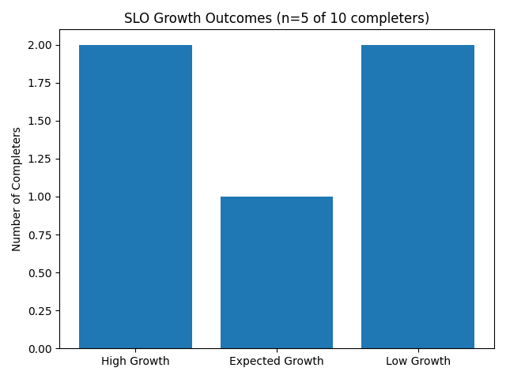
These results indicate that a majority of completers met or approached expected student growth targets. Variation reflects differences in student populations, baseline performance, and instructional contexts.
Completer Program Impact Surveys (2024-25 Surveys will be sent out soon. Data collected will be added to the website during the fall 2026 semester)

Measure 2: Satisfaction of Employers and Stakeholder Involvement
Links to completer and employer satisfaction surveys are provided on the program website:
Completer and Employer Satisfaction Surveys (2024-25 Surveys will be sent out soon. Data collected will be added to the website during the fall 2026 semester)
Stakeholders include P–12 administrators, mentor teachers, completers, and employers. Feedback is collected through surveys and ongoing partnerships and is used to inform program improvements, including increased focus on classroom management and special education practices.
Stakeholder feedback is used to inform continuous program improvement. For example, feedback has led to increased emphasis on classroom management and behavior strategies, as well as additional focus on special education practices within coursework and clinical experiences.

Measure 3: Candidate Competency at Completion (Title II Data)
Candidate competency at completion is demonstrated through performance on licensure examinations as reported in Title II data. The Educator Preparation Program (EPP) monitors pass rates across multiple Principles of Teaching & Learning (PLT) exams to ensure candidates meet professional standards.
Exam | Year | Number Taking | Number Passing | Pass Rate
K-6 PLT | 2021-22 | 39 | 38 | 97%
K-6 PLT | 2022-23 | 47 | 43 | 91%
K-6 PLT | 2023-24 | 34 | 34 | 100%
K-6 PLT | 2024-25 | 40 | 39 | 98%
7-12 PLT | 2021-22 | 11 | 8 | 72%
7-12 PLT | 2022-23 | 8 | 8 | 100%
7-12 PLT | 2023-24 | 5 | 5 | 100%
K-12 PLT | 2022-23 | 24 | 16 | 67%
K-12 PLT | 2023-24 | 19 | 19 | 100%
K-12 PLT | 2024-25 | 35 | 35 | 100%
Figure: Praxis pass rates by exam type. Results demonstrate consistently high performance across licensure areas.
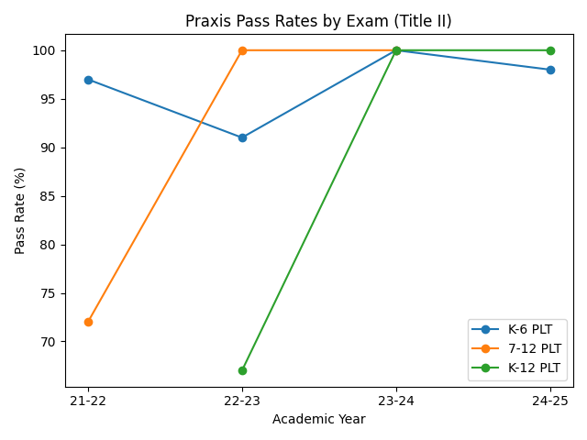
Overall, candidates consistently achieve high pass rates, often meeting or exceeding statewide averages. These results indicate that candidates are well-prepared with the knowledge and skills required for effective teaching practice.

Measure 4: Ability of Completers to be Hired (Multi-Year Program Trends)
Employment outcomes are presented across multiple years by program to demonstrate consistency and trends in completer placement.
Program | 2022-23 Employed | 2023-24 Employed | 2024-25 Employed | Placement Rate
Elementary Education | 15 | 33 | 39 | 100%
Elementary/Special Education | 9 | 12 | 21 | 100%
Secondary Education | 8 | 12 | 9 | 100%
Special Education | 0 | 0 | 9 | 100%
Figure: Multi-year employment outcomes by program.
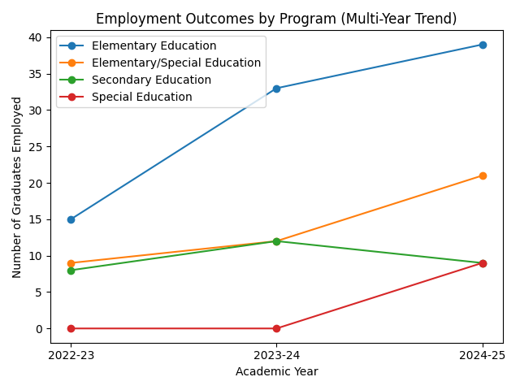
Across all programs, employment outcomes remain strong with consistent placement rates at 100%. The increase in employed graduates in Elementary and Elementary/Special Education reflects program growth and workforce demand. Special Education shows new completers entering the workforce in 2024–25, further addressing critical shortage areas.

Executive Summary
- Strong student learning impact demonstrated through SLO data
- High licensure pass rates (near 100%)
- 100% employment placement rates
- Continuous improvement driven by stakeholder feedback

CAEP Accredited Programs Since 2023:
Undergraduate Degrees:
- Elementary Education
- Elementary Education/Special Education
- Special Education
- Biology Education
- Business Education
- Computer Education
- English Education
- Math Education
- Physical Education

